The rights are:

- Know what is happening with your information
- Ask to see or have a copy of your information
- Ask for some of your information to be changed
- Ask us to delete your information
- Ask for your information to be transferred
to another organisation
- Ask us to stop using your information

Depending on the situation and the circumstances involved, there may be
some rights which do not apply. If this is the case, we will explain why.

Any Questions?

If you have any questions or want any further information, then you can
ask a member of staff at the Optometry practice.

If you want to use the rights available to you, access any of your records
or make a complaint you can contact:
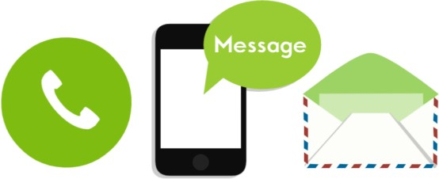
Optometry Manager | Richard Saunders
IG Lead | Richard Saunders
Data Protection Officer | DPOService@wales.nhs.uk

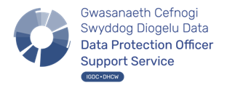
Version V1.0]
Last Reviewed: 26/03/26

Privacy Information for Children and Young People


Introduction

When you are a patient at our Optometry practice, we will need to keep some information about you to give you the best care and treatment. This leaflet will help you understand what information Saunders & Schwarz collects about you and how we keep this information safe.

What information do we collect?

- Name
- Address
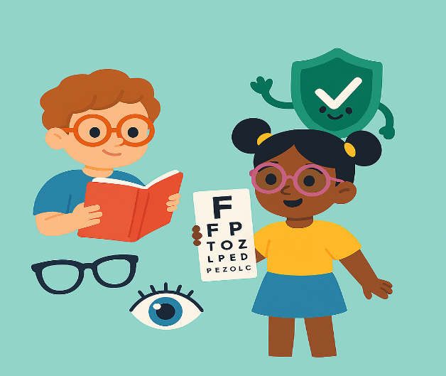
- Date of Birth
- Emergency contact information
- Name of the person that brings you to appointments
- Information about medicines and items you have been prescribed, which have been supplied by us
- General health history including allergies, medications, family eye health history, previous eye exams and treatments
- Vision and eye health data including tests, examinations or advice given
- The reason you are coming to see us and what we do to care for you

Why and how we collect your information

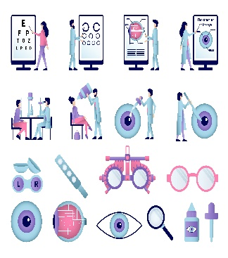
The Organisation’s purpose is to deliver healthcare to our patients. Our organisation and staff are members of your local healthcare team. We collect the data about your health and the care we have provided for you, so we can care for you in the best way.

To provide you with the best care possible we record information including details of the medicines and any other items (such as glasses) provided to you against NHS prescriptions, as well as significant advice we have given and details where we have made referrals to other health professionals.

We use this information to assess and monitor your eye health, provide prescriptions and treatment and communicate with you about appointments and care

Who do we share your information with?

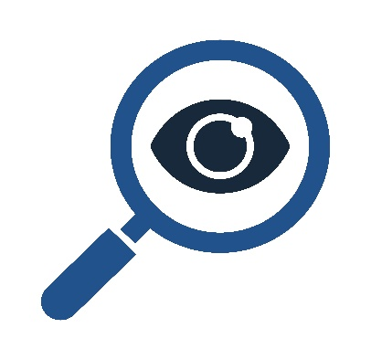
We will only ever use or share information with others if they are to be involved in your care and if it is important for your treatment or where we are required to by law, for example providing information to NHS Wales Shared Services Partnership who are responsible for validating prescription processes and payments to us. We will not give your information to anyone else without your permission, unless there are exceptional circumstances, or it is required by law.

We might share your information with other NHS organisations for referral, reporting and funding purposes, schools, social services and sometimes the police if necessary. This is to make sure all the people who care for you know exactly who you are and what you need.
Where we can, we will try to ask you if it is ok to do this. There may be times when we need to share this information without asking, because we are not able to ask you and it is in your best interest or because it needs to be done quickly to help you.

How do we keep your records safe?
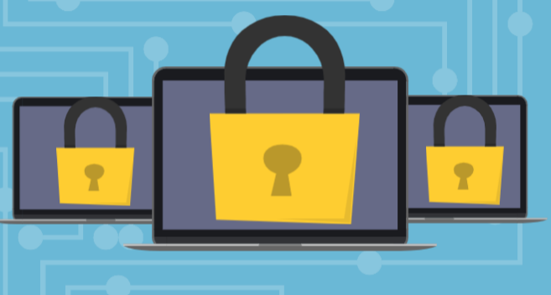
The Optometry practice must keep your personal information and records private.
The use and sharing of your information will be in line with the following
laws and guidelines:

- UK General Data Protection Regulation (UK GDPR) 2016
- Data Protection Act 2018
- Human Rights Act 1998
- Common Law Duty of Confidentiality
- NHS (Wales) Act 2006
- Health & Social Care (Wales) Act 2016
- Public Health (Wales) 2017

Every member of staff at the optometry practice must sign a confidentiality agreement and complete a training program every other year,
to be able to learn how to keep information about you safe and private.

What are your rights?


You have the same data protection rights as an adult.

If you are unable to exercise your rights yourself, a parent may exercise them on your behalf. Generally, if you are 12 years old or older, we will ask that you exercise your own rights or provide your consent for a parent
to do this on your behalf.

